Ladies and Gentlemen, You are all very welcome to our AGM which is being held in person and virtually over zoom. As Chair, it is my privilege to report and update you on the main activities of the Board of your Charity during 2022. First and foremost, I would like to thank the Lord Mayor, Daithí de Róiste and his staff for making available this wonderful setting for our AGM. This is the 2nd occasion that the Lord Mayor has welcomed us to this historic building for our Annual General Meeting, It builds on a great historical association between the Lord Mayor’s office and the City of Dublin Skin and Cancer Hospital going back to the early 1900‘s.
1 .Governance
As previous chairs have stated in their reports to the AGM, Governance is very important in running organisations and particularly, charities. The Charities Regulatory Authority commenced operations in 2016 and the regulator was encouraging all charities to adopt the Charities Governance Code. In 2017 on a plane trip a chance meeting took place between Professor Eoin O’Brien and Karen Erwin. Karen is a daughter of the late Major Thomas McDowell, a former Chair and CEO of the Irish Times and a Chair of the City of Dublin Skin and Cancer Hospital from 1969-1970. Eoin persuaded Karen to join the board of Charity Trustees and she was elected a member of the board in 2018. As Karen is retiring from the board at this meeting I want to pay tribute to Karen for her work in guiding us on the path to adopting the Charities Governance Code. She is leaving us after putting in place a robust set of governance policies. Thank you, Karen.
I would like to welcome Paula Duffy, who joined our board in October 2022.
As a Charity, we operate on your behalf as members, only through the Board. As regulation is placing more reporting burdens on organisations, charities, in particular are experiencing challenges in recruiting individuals to serve as charity trustees and I, in echoing previous chair’s appeal to you, our members, and friends, to encourage any suitable individuals that you are aware of, who might be willing to join the Charity and provide their expertise to our Board.
As in the past, I’m pleased to confirm that your Charity is in a strong financial position, it is well resourced to fund the many important initiatives and projects which we believe can make a substantial difference to the lives and wellbeing of many .

My update today will cover the range of activities we undertook at the Charity throughout 2022 in supporting our Mission, which is to create an environment to promote, endow, support and advance scientific research into diseases of the skin and the maintenance of skin health, and to facilitate the timely application of the resulting knowledge for the benefit of Society. Our strategy to achieve this by focussing the Charity’s resources into four key areas;
- Funding sector wide data analytics and information through the Skin Registry, known as NISR;
- Funding sector wide academic and clinical research into a range of dermatological matters
- Funding advocacy, education, and training across the sector, including scholarships and further education.
- Increasing public awareness and accessibility to support and knowledge on dermatological care.
I will highlight some of the tremendous achievements from these initiatives for you;
2. Applications to the Charity for funding
In his address to you last year, Battie White, advised that he had attended the formal presentation of the inaugural Paul Collins Fellowship to Dr Siobhan McCarthy, funded in the amount of €60,000 by the Charity. I am delighted to advise you that Dr McCarthy has taken up an appointment as a consultant in cutaneous allergy in the South Infirmary University Hospital in Cork.
Applications for funding are assessed by our Grants Committee and are independently reviewed by external examiners. We are confident that the projects we support are deserving and appropriate for grants from us.
We provided education support to the Irish Dermatology Nurses Association (IDNA) of €10,000.
We maintained our funding of bursaries, valued at €45,000 for the training of Specialist Registrars, whom it is hoped will become Dermatology Consultants in the public service in Ireland in the future. These bursaries are awarded on the recommendations of the Dermatology Training Committee of the Irish Association of Dermatologists.
3. Projects supported as part of the IAD training scheme included:
- The travel fellowship award was carried over to 2023.
- Dr Olga Tummon for a project on “obesity in chronic skin disease”.
- Dr Elizabeth Keeling for a project on the “quantification of neutrophil elastase activity in Hidradenitis Suppurativa (HS).
- Dr Greg Murray for a project on” profiling and identifying risk factors for cutaneous immune -related adverse events in patients with malignant melanoma treated with immune checkpoint inhibitors”.
- Dr Amy Ridge for a project on “coeliac disease and alopecia areata”.
4. Research projects supported in 2022-2023
- A further €20,000 to the Mater University Hospital (MUH) for its project on skin models to be used in educating the next generation of those involved in diagnosing diseases of the skin.
- €87,356 to the Charles Institute for a project on Functional analysis of inflammasome protein mutations in the inflammatory skin disease Hidradenitis Suppurativa (HS).
- €171,015 to St Vincent’s University Hospital for a project on reducing the burden of kerinatocyte, an innovative approach.
- €171,674 to St Vincent’s University Hospital for a project on personalised medicine in inflammatory dermatological disease
- €189,506 to Trinity College Dublin for a project on Targeting cellular metabolism in Hidradenitis Suppurativa (HS).
- €88,567 to Tallaght University Hospital for a project on A translational research investigation exploring the immunomodulators, inflammatory mediators, tissue remodelling and development of scarring in Hidradenitis Suppurativa (HS).
In total €728,118 has been committed by your charity towards fulfilment of one of the main objects of the charity “research into diseases of the skin and their treatments”
Your charity will continue to fulfil the obligations of Charter 2008 whenever a suitable project that meets its objects is placed before our grants committee for funding.
5. National and International Skin Registry Solutions (NISR)
Prof Eoin O’Brien championed the establishment of skin registries in 2000 and in 2021 your charity committed €3,000,000 towards their establishment. Their chief executive officer Godfrey Fletcher has reported on their performance for 2022 as follows:
Operations – Registries
During 2022 NISR Solutions consolidated and further developed the five dermatology registries that were deployed in 2021. The status for each registry as of the end of 2022 is summarized below.
EB Registry
The EB Registry has recruited the full complement of 49 patients available to the registry that attend CHI-Crumlin. Focus has moved to collecting retrospective data on those patients’ attending clinic on a weekly basis. The scientific team is now reviewing the dataset and software to evaluate what improvements can be made to the extraction and reporting of data trends. The process for establishing a dataset for adult patients has been slow and frustrated by the fact that there is no specialist consultant responsible for adult patients in St James’s Hospital. The registry is working with the nurse specialist and with DEBRA Ireland to promote the EB registry to adult patients attending the hospital. There have been some early approaches from pharma to investigate the potential of using Irish EB Registry data as part of a Post Authorisation Safety Study for the European Medicines Authority. It is positive to note that industry is aware of the registry and if this particular drug does not break through then others will follow the same procedure.
AD Registry – ASTAR Ireland
Ethics approval was received from St James’s & Tallaght University hospitals as well as Cork University Hospital – South Infirmary, The Mater Hospital and Galway University Hospital. Responses have been submitted to the St Vincent’s University Hospital ethics committee and we are waiting for a positive response. The registry will expand to other centres once the existing centres have become familiar with the consenting and data collection process. The ASTAR Ireland registry has received.
special project funding for the Irish portion of a pan-European project to create a federated data model across 5 European countries. The funding of €112,654 received from Pfizer is to cover the technology cost and project specific operating costs. The emphasis now is to increase patient numbers on the ASTAR Ireland platform. Expressions of interest have been received from other pharma companies’ dependent upon data being available. The specification for a Patient Reported Outcomes Module (PROM) has been completed and development and testing will take place in early 2023. This will greatly assist with the speed and efficiency of collecting and scoring various quality of life surveys that are required for the registry.
Alopecia Registry – GRASS
Ethics approval has been received for Hair Restoration Blackrock, Cork University Hospital – South Infirmary Hospital and Mater Hospital. Seventy-seven patients have been recruited and data is now being collected. GRASS is part of an international project and a grant of €30,000 was received towards this project from the Australian Hair & Wool Research Society during 2022. Dr Dmitri Wall attended the World Conference for Hair Research in November 2022 making three presentations and a number of abstracts. NISR is recognised for its contribution towards the establishment of an international Alopecia Registry.
COVID Registries for Atopic Dermatitis & Alopecia Areata – Secure-AD & Secure-AA
Both of these international collaboration projects investigated the effect of systemic immunomodulatory treatments on COVID-19 outcomes in patients with atopic dermatitis (AD) and alopecia areata (AA), using a global registry platform that NISR had developed. The results of the Secure-AD project were published in the Journal of the European Academy of Dermatology and Venereology in 2022. The Secure-AA project ran a little longer and the data is currently being analysed and prepared for submission for publication. Both projects proved very beneficial in developing contacts and cementing international collaboration for NISR with international experts.
Website & Social Media
The NISR Solutions website is available at https://www.nisrsolutions.com.
NISR maintains an active presence on Twitter and LinkedIn.
Publications
During 2022 NISR published papers in the following scientific journals.
The effects of systemic immunomodulatory treatments on COVID-19 outcomes in patients with atopic dermatitis: Results from the global SECURE-AD registry.
Musters AH, Broderick C, Prieto-Merino D, Chiricozzi A, Damiani G, Peris K, Dhar S, De A, Freeman E, Arents BWM, Burton T, Bosma ALL, Chi CC, Fletcher G, Drucker AM, Kabashima K, de Monchy EF, Panda M, Wall DR, Vestergaard C, Mahé E, Bonzano L, Kattach L, Napolitano M, Ordoñez-Rubiano MF, Haufe E, Patruno C, Irvine AD, Spuls PI, Flohr C.
J Eur Acad Dermatol Venereol. 2023 Feb;37(2):365-381. doi: 10.1111/jdv.18613. Epub 2022 Oct 12.
PMID: 36169355
Signposts to the Promised Land in Alopecia Areata.
Wall D, Rees H, Bokhari L, Meah N, York K, Sinclair R.
J Invest Dermatol. 2023 Jan;143(1):9-10. doi: 10.1016/j.jid.2022.08.031. Epub 2022 Sep 17.
PMID: 36123183
6. Investments
Stephen Walsh, our honorary Treasurer, will update you on the financial operations of the charity in the past year.
I am fully aware that this will appear repetitive, however it is very hard to find a different way of presenting it, but with the input of our investment managers and our Finance and Operations Committee, we continue to take a prudent, conservative approach in all investment matters, and endeavour to spread the financial risks to our funds through diversified and separately managed investment portfolios.
7. Charles Institute
Your charity in partnership with University College Dublin established the Charles Institute for dermatology in 2010. Prof Desmond Tobin Director has advised me on progress in the Institute as follows:
“2022 was my 4th year as Director at the UCD Charles Institute of Dermatology. With the COVID pandemic now thankfully behind us, we largely returned to our more usual interactive research atmosphere of in-person meetings, conferences, PhD examinations etc. We continue to avail of Heath Education Authority-supported PhD student project extensions, for projects delayed due to COVID restrictions. That said, laboratory research costs, inflated during COVID have not sadly returned to pre-COVID norms. Here below follows a brief mention of some highlights and key issues relevant to 2022 activities in the Charles Institute.
Research funding:
- New grant awards in 2022 amounted to €1.26 M; up from €935K in 2021.
- Some highlights include a 2-year postdoc from Louis Vuitton-Moet-Hennessey in France to look at the effect on UVR on skin;
- a PhD student funded by the CDSCHC to assess the role of blister fluids in wound healing from scald burns;
- a 2-year Newman Fellowship from Sanofi Pharma to assess the role of hair follicles in RDEB wound healing (together with Dr Fiona Browne),
- and an HRCI-HRB grant to look at a new approach for pain and wound management in patients with RDEB.
- 2022 saw 3rd (of 5) year funding from CDSCHC for the Skin Disease Registry (NISR).
Publications:
2022 was another very successful year for UCD Charles Institute-affiliated publications with 57 articles published in international peer-reviewed journals (down slightly from 61 in 2021). These included publications by affiliated dermatologist colleagues via the UCD’s School of Medicine’s Clinical Pathway and represents an important route to share with the wider world our research here at the Charles Institute.
Our Researcher Community:
We had 40 researchers operating in the Charles Institute in 2022. However, we have capacity for 25 more researchers and so have opportunity to grow.
- Prof. Dimitrios Zeugolis (ex-NUIG) joined UCD School of Mechanical and Materials Engineering in July 2021 and continues to settle in, with now 3 PhD students based in the Charles working on wound healing research.
- We recruited 6 new postdoctoral level researchers in 2022 (up 1 from 2021) and 2 new PhD/MD students. Researcher recruitment continues to be very challenging, due to dire accommodation situation anywhere close to UCD.
- Our efforts to recruit to a permanent post of Assoc. Professor in Skin Cancer were unsuccessful in 2022. An offer was made in each of the 2 rounds completed, but sadly offered candidates declined. Round 3 will conclude in mid Dec 2023 (at time of writing). Dermatology Education Program: (aimed at upskilling GPs in common skin diseases).
- Our Professional Certificate in Clinical Dermatology, now led by Consultant Dermatologist Dr Rosalind Hughes recruited its third cohort of 164 students (1 in 5 of these are non-EU students).
- Our teaching faculty consists of 20 Consultant Dermatologists from across the island and they provide content pro-bono.
Charles Seminar Series:
- We ran our 4th season, mostly in person. Audience includes UCD researchers, IAD members, previous speakers, and students on our Prof Cert in Clinical Dermatology. This series was supported again by an unrestricted educational grant from A. Menarini Ireland. We had 17 speakers (6 from Ireland, 5 from GB, 2 from China, and 1 each from Portugal & Switzerland.
- Seminar synopses were written up by a medical journalist and published in Medical Independent (print/online). The second compendium of Charles Seminars was published by the Medical Independent in 2022 and widely distributed, including to IAD membership.
Key changes to Charles Institute Operations Team:
- We bade farewell to Mr Ronan Gough, who after 4 years with us moved on to a higher grade position elsewhere in UCD.
- We welcomed Ms Éadaoin Scully as our new Senior Executive Assist. in March 2022 but sadly, she left for a permanent position in Emergency Medicine in December 2002.
- We bade farewell in October 2022 to our Technical Officer Ms. Melissa Daly, who after struggling with housing pressures in Dublin emigrated to Australia.
Significant New Equipment obtained for the Charles this year:
- Water purifier (€20K).
- Charles awarded €106K (from the UCD Equip fund) to replace current liquid nitrogen storage with safer, more temperature-stable cryofreezers (-150oC)
External Reach:
- The key event of 22 was the Irish Melanoma Forum held on May 2022 in the UCD O’Reilly Hall (& in hybrid form). This was the first meeting with Shirley Potter and Des Tobin as the new Irish Melanoma Forum co-chairs.
- The meeting was very successful, with a total of 304 registrations with 240 in attendance and107 attending online. Meeting sponsors included Bristol Myer Squibb; Novartis; MSD; Merck; Pierre-Fabre; and L’Oreal. Also exhibiting at the meeting were Irish Skin Foundation; Cancer Trials Ireland; Melanoma Support Ireland; and the Irish Cancer Society. A total of 65 abstracts were submitted.
- The Charles Institute was awarded a “My Green Lab Certification” (Platinum level – second highest). My Green Lab Certification is considered the gold standard for laboratory sustainability best practices around the world and is UN recognized. We are first in UCD to get this mark.
Charles People in the spotlight:
- Contributions of Prof. Eoin O’Brien to medicine were celebrated in the Charles Institute, hosted by the College of Health and Agricultural Sciences in May 2022. The event was accompanied by the unveiling of the Robert Ballagh-painted portrait of Eoin by then UCD President Mark Rogers.
- Des Tobin was appointed member of the Life & Health Sciences Committee at the Royal Irish Academy, and also Chief Editor of the Skin Physiology section of the journal Frontiers in Physiology.
- I was involved in some media during 2022 including radio interviews on BBC Radio 4’s “The Curious Cases of Rutherford and Fry”, and Ireland LM/FM, as well as TV interview from the Kevi Barry Gallery on RTE Science Week TV Program: ‘Future Island'.
- I concluded a sub-panel membership of the UK’s Research Excellence Framework 2021 audit in Feb of 2022. This audit informs the disbursement of £15 billion in research funding by the British Treasury to UK-based universities.
- Prof. Wenxin Wang started a 1-year sabbatical in China in Sept 2022, having received the prestigious ‘Yangzi Overseas Scholarship’ from the Chinese Education Ministry.
8. Irish Skin Foundation (ISF)
The Irish Skin Foundation (ISF) gratefully acknowledges the support of the City of Dublin Skin and Cancer Hospital Charity (CDSCHC) and would like to express their particular thanks for the confirmation of ongoing funding for core work which assists it a maintain organisational independence.
Fundraising and partnering with industry.
The ISF’s Foundation Partnership and Corporate Sponsorship Fundraising model remains very successful overall, underpinned as it is by a strong demonstrated need for the ISF Ask-a-Nurse Helpline (see below) and viewed as a robust value-for-money proposition by our partners. In 2022 we successfully submitted funding application for 7 corporate sponsors to the value of €135,000.
We anticipate some income fluctuation and difficulties in maintaining this level of support for the Ask-a-Nurse Helpline as companies, particularly those with joint Irish-UK corporate or sales structures, pull back from charitable donation and support of patient organisations against the background of a turbulent 2022 and 2023 economic environment. LEO Pharma has decided not to continue its support for Foundation Partnership in 2023, the decision was made in the UK and follows several years of change, as operations and decision making for the Irish market has progressively moved to the UK.
Expressions of interest have been made by Boehringer-Ingelheim, Bristol Myers Squibb, and Janssen.
Helpline
The ISF Helpline performed well in 2022 when we received 927 enquiries resulting in 788 one-to-one phone-based consultations with our Helpline nurses, typically 20–50-minutes in duration depending upon the complexity of the issue being addressed. While this total of 927 enquiries represents a 17% decrease on 2021 (an exceptional year driven primarily by fear of the implications of Covid-19 for immunosuppressed patients) it is however an increase of 15% on 2020. Quality of service remains consistently high at 95-99% and feedback from the public continues to be extremely complimentary. 2023 has seen a strong start to the year with 259 Helpline clients assisted in the first quarter with queries on eczema (16%), psoriasis (14%), acne (7%), rosacea (4%) and other skin conditions (32%). 27% off all enquiries are from patients without a diagnosis.
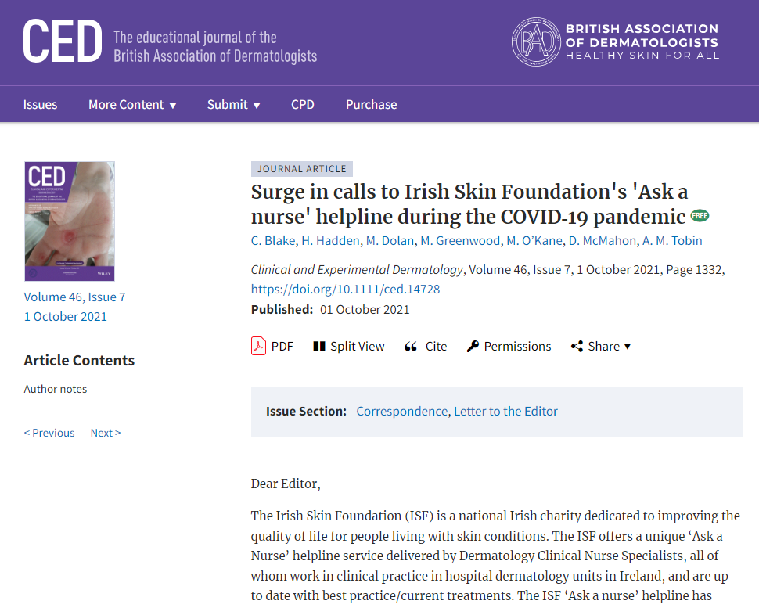

Blake, C., Hadden, H., Dolan, M., Greenwood, M., O'Kane, M., McMahon, D., & Tobin, A. M. (2021). ‘Surge in calls to Irish Skin Foundation's 'Ask a nurse' helpline during the COVID-19
pandemic’. Clinical and experimental dermatology, 46(7), 1332. https://doi.org/10.1111/ced.14728

Public Consultation:
Our public consultation concluded in September 2022 and received 419 responses from people of all ages, including patients, carers and others interested in dermatology conditions, throughout Ireland. 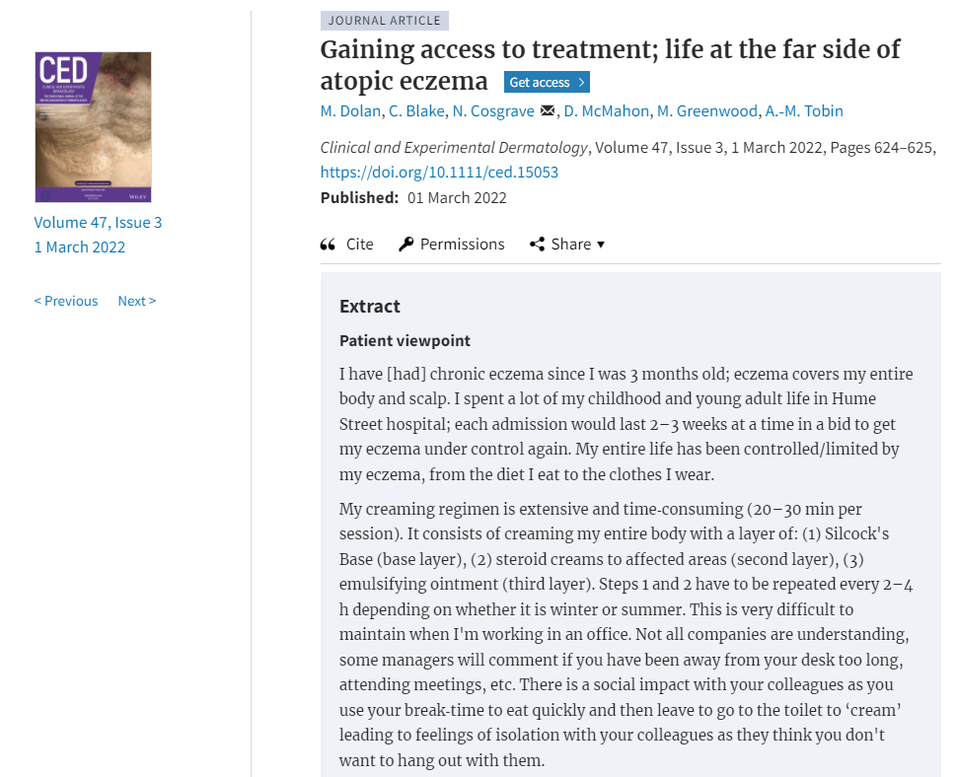
Dolan, M., Blake, C., Cosgrave, N., McMahon, D., Greenwood, M., & Tobin, A. M. (2022). Gaining access to treatment; life at the far side of atopic eczema. Clinical and experimental dermatology, 47(3), 624–625.
https://doi.org/10.1111/ced.15053
We sought out the views of as many people as possible to inform our advocacy and health promotion work. This was a particularly valuable exercise terms of the ISF assessing how we orient our work and focus.
Advocacy and Policy Development:
- The ISF made substantive and detailed policy development submission incorporating suggestions for consideration for the new National Skin Cancer Prevention Plan 2023+, submitted to the National Cancer Control Programme (NCCP) in September 2022. We made 16 recommendations, each with an evidential base, which included: mention of skin of colour and differences in risk, integrating and leveraging the power of a cross-promotional messaging approach for prevention and early detection, expanding target groups to include/give specific mention to transplant recipients, arguments in support of an outright ban on sunbeds, altering perceptions of the benefits of tanning, and suggestions for further research.
- ISF/ULHG SunSmart video research collaboration: Ms Evelyn Power Skin Cancer CNS and colleagues at University Hospital Limerick presented research findings as a Poster Presentation Abstract ‘The impact of a visual sun protection campaign on sun-related attitudes of healthcare workers,’ at the British Dermatological Nursing Group Annual Conference in the UK, and at the Irish Association of Dermatologists Autumn meeting, both held in September. Ms Evelyn Power also presented at the Irish Research Nurses and Midwives 14th Annual Conference on November 10th, 2022, in the Strand Hotel Limerick, winning best speaker for her presentation, titled: The Impact of a visual sun protection campaign on sun-related attitudes and behaviours of Healthcare Workers - A Nursing Initiative.
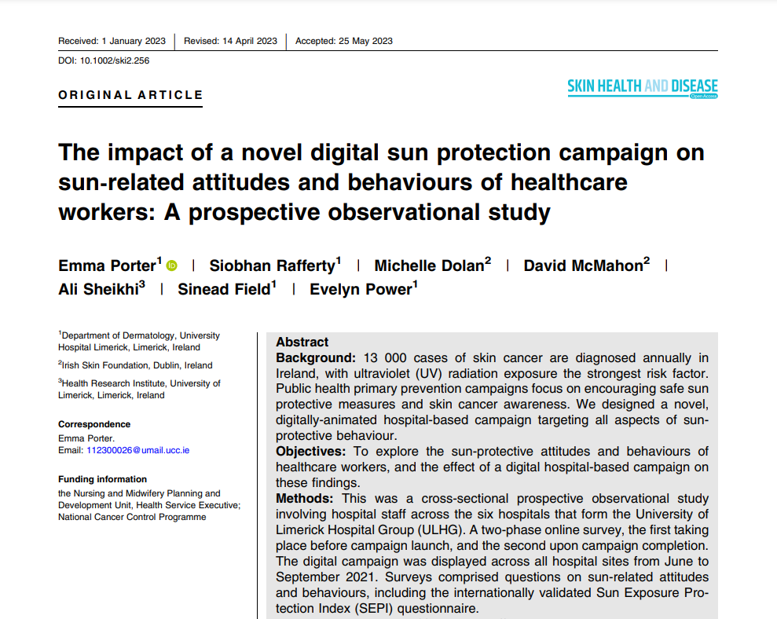

Porter, E., Rafferty, S., Dolan, M., McMahon, D., Sheikhi, A., Field, S., Power, E. (2023). ‘The impact of a novel digital sun protection campaign on sun‐related attitudes and behaviours of healthcare workers: A prospective observational study,’ Skin Health and Disease, 2023; e256. https://doi.org/10.1002/ski2.256
ISF Submission to the Census 2027 public consultation: In our submission to the NCCP re the new Skin Cancer Prevention Plan 2023+ last September, we had suggested seeking to include a question(s) in the next Census about protecting skin from UV. The Central Statistics Office (CSO) invited submissions on the content of the form for the 2027 Census of Population, after reviewing a wide range of national and international surveys in preparation, the ISF made a formal submission for consideration in January 2023.
Research Projects:
ISF Psoriasis Survey: We hope to launch this study in late 2023 or in early 2024. We are very pleased that the ethics application for the ISF Psoriasis Survey received full approval from Tallaght University Hospital Ethics Committee on in January (2023). Working with Profs Anne-Marie Tobin and Brian Kirby the survey has been expanded to include some questions that mirror those from the Census, which could be very useful for comparative purposes e.g., re issues such as intergenerational disadvantage, the digital divide and access to services. We are also very grateful to have received permission for inclusion of the following validated measures:
Dermatology Life Quality Index (DLQI) – Prof Finlay Cardiff University
Psoriasis Epidemiology Screening Tool (PEST) – Professor Philip Helliwell University of Leeds
MacArthur scale of subjective social status – Stanford SPARQ
BioMap: BioMap (an international psoriasis and eczema research project) held their annual meeting in October in Kiel, Germany. The ISF attended both days virtually. Updates and highlights on various Work Packages taskforces (severity, co-morbidities, disease trajectory and endotypes) were delivered over the two days.
Community Outreach:
- Mater Hospital Eczema Awareness day: The health promotion team were delighted to be invited by Ms Emma Byrne Dermatology CNS, to support their eczema awareness stand in the Mater Hospital and mark World Eczema Day in September.
- Fettercairn Community Health Project, Tallaght: Samantha Griffin, Project Co-ordinator for the Fettercairn Community Health Project, reached out to the health promotion team, with the request to provide two talks for their community members in Fettercairn and Killinarden in October; the talks included general skin health, skin cancer prevention, and two of the most common inflammatory skin conditions, psoriasis, and eczema.
- Dundalk Institute of Technology (DkIT) Health Fair: The health promotion team were invited back by Student Health Unit nurses Patricia Smyth and Judith Bradley to support their Health Fair for students and staff held on the DkIT campus in January.
Founding charity trustee and Chairperson since 2017, Dr Marina O’Kane stepped down from the ISF Board in November 2022, Ken McKenzie PhD, a member of the Board and patient representative has been elected Chairperson and Prof. Anne-Marie Tobin elected Vice-Chairperson.
9. Conclusion
I am sorry to advise you that recently a long serving board member and a pioneering friend passed to their eternal reward:
Padraig O’Cearbhaill: Padraig served the charity for almost 20 years, as a board member, treasurer, chair, committee member and friend. He was responsible for encouraging me to join the board. Battie White encapsulated our thoughts when he commented that Padraig was a kind and valued colleague, his advice and guidance will be sadly missed.
Professor Sarah Rogers: it was with great sadness that we learned of the passing of Sarah. Sarah was a great friend to the charity and to the hospital that she served so faithfully from 1979 until its closure in 2006. She probably was responsible for ensuring that the hospital did not close down in the early 80s because of introduction of phototherapy treatment. She raised the profile of dermatology in Ireland.

